***SEO (SEARCH ENGINE OPTIMSATION)***

**Parsley compelted(1.0 beta Version)**

***All the answer are based on my undersanding if anything seems to wrong(info me, I will update)***

1. **what is SEO**

SEO is just a tool or engine or technic used by google or yohoo search engine for extracting the data from meta Tags and use that meta tag information to matched with user Seached text if both match then our site will be showen in the 1st list

1. **how its work**

when we talk about Google , google use something like scrawler or something like robot and these robo goes into all website and just see the meta tag only and use that meta infromation

for showing the result/webpages to users by matching the user seach text and meta tag content

1. **how SEO work with React APP**

SEO simplity work as it work with other language, it doesnt Treate any language high or low, when comes to React.js language, it just goes to index.html file and just goes into head tag and read all the meta tags and notes all the meta tags and match them with user searched Text, if both user text and our meta tag content both matches then our React will be showen 1st in the React

1. **Problem with React APP**

Problem with React APP, google robo, may also sometimes goes into the body content(complete website, not only just meta tags) but in our react app, we dont have anything in the html file , content in body, all our code will be present in the bundle.js file, so if we have relevent content also, Google robo cannot find it and our site may not comes into list ( see upcomg photo, i explained)

1. **#Role of the Meta tags**

Meta tags are not shown in the page, but its machine parsable it means, google robo/crawlers will use these infrormation

1. Example :
2. <meta charset="UTF-8">  
   <title>This is the meta title tag. It can be 45-60 characters long</title>

<meta name="description" content="This is the meta description. The maximum length is somewhere around 150-160 characters, but Google often pulls a description from your page content." />  
  <meta name="keywords" content="HTML, CSS, JavaScript">  
  <meta name="author" content="John Doe">  
  <meta name="viewport" content="width=device-width, initial-scale=1.0">

1. When we don’t have any scheme Object in our project then Google will use these meta tags for displaying the rich content in the Google search for example see the below example
2. 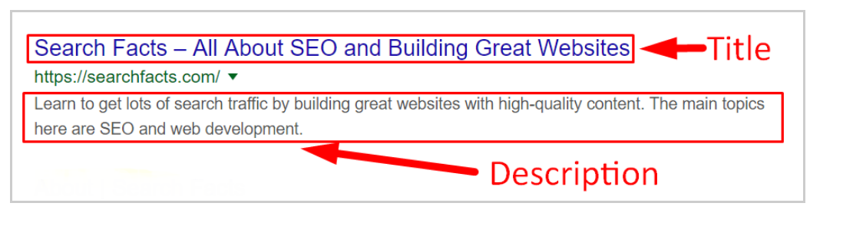
3. To learn about meta tags <https://www.w3schools.com/tags/tag_meta.asp> visist these page
4. when user type something in the google seach and when these title or description match with the user search value then our website will come in top in seach results
5. **React Pre-rending**
6. As per my last talk(4 point Problem with React APP), i told helmet Componet is waste, but we can achive or make helment component powerfully by these 3rd-party tools i,e pre-rending the App, as it happen in the next.js language all the js file code is compiled and dumpped into the index.html file
7. Google is saying that we are doing our best with js langages(like react) to work with SEO( as i told problem with clinet-side-rending problems), now Google saying we are trying our best to solve these problem, in my opnion Google is trying but in react app, the pages are render when user demand, untill no page is loaded on DOM, so it diiffult for SEO for get meta tag becoz we have wrote the meta tags in helment componet which is in js file (components) loaded when user demands the pages, so it become diffult for the google scawlers for get meta tags so our react app as these drawback, to overcome these problem , we use pre-rending techinques in the React app, see upcoming points too get more idea what im speaking
8. so use Next.js language , which as super support for the seo i.e its completely dum the js and html code in the index.html fite (it doesnt create any script tag)
9. **#Importance of the <a> and img and video tag in SEO**

As per my previous talk, i told Google robot will go into body content also, so if we use any enternal link in href the google robo will follow that link, here Theme is dont use the href stiuff in span or h tag, if u want to use the href then use it in only a tag, its recommeneted by the Google and its mandtory to use alt text for the image and video and its recommed by the Google also

and Google Robo will follow the link which we mentioned in the href attritube in the a tag

NOTE : A web crawler is a program, often called a bot or robot, which systematically browses the Web to collect data from webpages. Typically search engines (e.g. Google, Bing, etc.) use crawlers to build indexes.

1. **#React Helmet Component**

If we want to use meta tags dynamically in react app , we can use helmet component, when we do that, it has so many draw back like when we talk about client-side-rending then these helment component is loading when the user demand the page, untill user doesnt demand the page, these meta tag which are present inside of helmet component, is not load into .html page and it doesnt play a major role in SEO becoz google crawler doesn’t know about the meta tags, these meta tags are loaded when user demands the page, helmet component is usefull when our react.js code is completed embeded into html file as it happens in the next.js then helments components shines and in my opion, helment is usefull just to give user a illustation that we are in these page or other page by changing the browser meta tag title and soon

my opinon Helment doesnt play a major role in the SEO ( edo unndi anthi unndi anthi)

example :

<Helmet>

<title>App Title</title>

<meta name="description" content="App Description" />

<meta name="theme-color" content="#008f68" />

</Helmet>

And

it used to inject the meta tag into the index file of our project dyanamicaly anthi helment Pani But its not so usefully for SEO , just for user interface ki edo browser titlle chnage cheyadam and edo light stufff ki paniki vasthi, (plz see above explanation, i explained in great deatiles about helmet problem with react clinet side rendering, ( NOTE : React.js is not pre-rending language, its contents are load on demand when user demands

and

**How to Overcome these problems**

NOTE: helment component becomes powerfull if we pre-render the react project, then helment becomes king, becoz all the components are evaluated including the helmenet component in the server and we get static page from the sever and helement (meta tags) are inserted dymamically into meta tags then it shine so much

And pre-rending happens when we use third party website for help

Or

Just for Next.js language( which has pre-build mechanision that is all the js and css are dumped directly into index.html file, it doesn’t created any bundle.js file extranal file, as happens in React.js language

1. **#Possible solution for Optimise The React App for SEO**

1st possible Way is we must use another 3rd party service like pre-rendering site so that our react code will completely dumm into the index.html so that all the helment code will be parsed and placed into the head tag of the index.html

2nd possible way is we must use another npm package(these npm packages help us in pre-rending the React App i.e our react code will completely dumm into the index.html) and if we want to improve the SEO performance if we are using helment

Example

Npm package are : 1) react-snapshot

For more information about react-snapshot please vist the npmjs.com official website and in photos(pdf /word file) I have explained some of the keypoints in the about these package, if ur interested plz checkout the pdf/word file or just vist npmjs.com

***Few Important Points About the Google Ranking for Webiste***

1. **#SEO Tool and Plugins**
2. Google analyisis( something that is google tool) whcih help us to analaysis the our website ( like what traffic we should get and etc...........)
3. yoast SEO plugin (mostly used with wordpress) make our work easily, like its perpare scheme data and optimisation for seo and so-on for us
4. google keyword planner is a offical tool of the Google, which help us to get suggestion(note: these tools are used for google ads or business
5. **#write html code in these way**

1. mana sub-title(h2) and title tag(h1) same uundali, its suggest by google and its help us in google seo and ranking NOTE : below that description/content(p tag) must and should have 100 words in a great/rich way
2. Make our that our content is also be in upto date that, what user want and according to him/her just change the content( h tag and p tag(description and title)
3. the website which are mobile friendly, will get the ranking from the google SEO
4. write the trending keywords in our website
5. think something beyond the trending keyword so that our website may come top in search results
6. if u have a page that u really want to rank , make sure it conatin alteast 1890 words of aweson content
7. Haviing lots of un-nessary content in the webpage make ur website bad in google ranking and for seo
8. **About website regarding the SEO**
9. If our website loads faster then our website will rank in top
10. If we get hight click to our website then our website will comes 1s in the results
11. Promt ur website
12. when we write description its must be in a Good way that is we must need break the content so that user can read the content in good way and google will feel the our website is good and user will stay for long time in our website ( and always don’t write the contnt without <br/>, always make sure that ur website description has line breaks)
13. we must need to use the video, images and etc.. in our website it will boost our website and help in google ranking
14. use extranal links in our website, it will help us in google ranking
15. use the another popular website which most of people vist daily, then deal with that website and tell them to keep our website link in they page and so that we get high traffic
16. prompt ur website for example : give ur link those webiste which are releated to our caterogy, supoose our website(user app) is realted to hosiptal then if we promst our link in another top website of hostpal, its wroth, but if we post website link in airline or shopping, it may not wroth
17. we must tag big people or big company in our website , ( like in b2p we may tag flipkart or amozan ) it help us
18. note: if user stay long in our website , then we get high ranking, if user click and leave the page in same time, then google comes to know that, our website is not best sutted for that user typed keywords, then from that on-wards our website will not come in top for that keywords
19. break ur content and make sure that have subheading in content itself( so that user can read what they want) anthi, motham content user cannot read he may have less time, so make ur description into small chunks and add subheading
20. when u create a high value resources, people will want to read it , even if its long
21. if u have a page that u really want to rank , make sure it conatin alteast 1890 words of aweson content
22. Haviing lots of un-nessary content in the webpage make ur website bad in google ranking and for seo
23. Use wikipedia for the searching the rich keywords
24. when we give sub url name(router) before that we must need to search for the that sub url name in google , if its in demand and its in used by the most of people, by searching then we msut use or decide or give the names to sub-url
25. title lo no and [] or % , we must need to use, these makes / boost our website ranking in google
26. tell blogger to keep our website links in their blog so that we get high user redirect to our website
27. write the title in such way that it should match the our website content
28. if our website is loading slowing then we may get negative ranking from google ranking so our website must and should load fastly or above average then we will get good ranking from the Google(these words are saided by the Google employ, not me)
29. to rank in the Google , cover all the topics, which ur showing, in ur article or website
30. 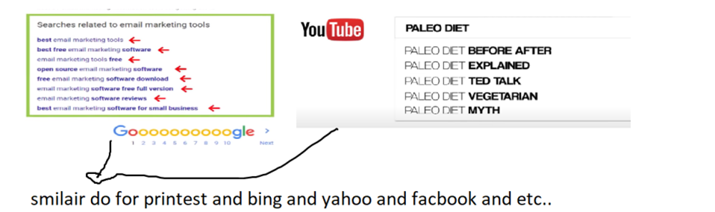for rich keyword, use these google yahoo and facebook keyword suggestion and use them in our website
31. Keep in mind :

if we have title with words like high quality hostiptal and if user type just high quality, our website will come in top but user is want high quality tv or just type high Quality TV, then our website will drop or our website will not come in google search/ results, in these way only google ranking works but when any user type high quality hospital the our website will come 1st and if any search the high quality just hight quality next time then, our website asalu raddu, if we have suffic hostipal at end then only our website will come in top , in way only google works

1. **Website testing tools**

1. Google rich testing tools
2. Webpagetest.org
3. Gtmetrix.com

***How Google Gives Ranking to the Webiste***

1. **New website vs old website**
2. If our website is new then it will take time to come into top result and if the website is old then it will take less time to come in Google search,i.e to come top in search result NOTE: these words are sayed by youtuber, not by me
3. if we have less competitive and we have very good words(keywords/meta data) in our website then our website will come 1st in search result
4. we must need to be clear about what we are targeting, google voice search or google seach or google assistance, so ranking also depend on these factor also
5. if our website is new site then it will take 9 to12 months of time or less than that, if and only if we follow the standard approach of the SEO, ( NOTE: if we use any black magic(illegal ways then it may take more than 1 years also)
6. if we are targeting new keywords , then our website may come 1st in the page (not in 1st place but in 1st page) becoz no one is using those new keywords in thire website so our website will come fast
7. If we are targeting a keywords which is mos popular and all the website are using it, and we are also using that keyword in ur website then it will take much time and we have huge competitor for our website
8. competitive keywords if we have old website then it may take 3 months only and if we target non-competitive words then it may take very less time
9. target the words, which normally all user typeor search in google seach
10. use snipppets like google rich testing tools for testing
11. we must have avg speed atleast   
    ( note : google doesnt rank on speed of website loading but if its loading slowing then its ranks goes down)

1. **For Google Ranking use these thecanics**
2. mana webiste doamin name and mana website lo vaddi keywords/content same unndi
3. our website should not load slowly, if its load slowly then google will rank it below, so we must have avg speed atleast ( note : google doesnt rank on speed of website loading but if its loading slowing then its ranks goes down)
4. when we search for a words in google search bar, then google will give suggestion to us, so just note these words and use these words in our projects
5. NEXT, YOU WANT TO MAKE SURE THAT YOUR CONTENT IS AT LEAST 1,890 WORDS LONG.
6. description antha baga unthado, antha baga traffiic ravala and description all the words a-z brif explantaion undali then google search lo manam website vasthadi becoz, our website content /description matches all the words which user is typed in google seach bar
7. NOW THAT YOU'VE PUBLISHED AN AWESOME PIECE OF LONG-FORM CONTENT, IT'S TIME TO OPTIMIZE IT AROUND YOUR TARGET KEYWORD.
8. NEXT, INCLUDE YOUR TARGET KEYWORD ONCE IN THE FIRST 100 WORDS OF YOUR ARTICLE.
9. extrnal href links we must add to our website, it help google to give ranking to our website ACTION TIP
10. when user click on the our website url, or in another words, when user open our site, then our site may go up in ranking becoz google give ranking for our website
11. if our website comes in top search result and no one lstay in our website for long and goes back then, our site will goes down
12. we should give advancement about our website in social platform, so that our website will get high click and rank on the top search result in google
13. use those keywords which are now so popular in current time like Works quickly Step-by-step, Easy Quick Simple.
14. USE CONTENT MARKETING TO INCREASE YOUR ECOMMERCE SITE'S OVERALL DOMAIN AUTHORITY. THAT BOOST IN DOMAIN AUTHORITY WILL INCREASE THE RANKINGS OF YOUR PRODUCT AND CATEGORY PAGES
15. 1st get extranl links to our page 2nd find the browen links( which are not working now, just remove them from the webpage) 3rd Nothing
16. NEXT, YOU WANT TO MAKE INFOGRAPHICS PART OF YOUR CONTENT MARKETING.
17. Anthi , we must need to use graph and pie chart in our website so that google will give high ranking to us
18. If we get high click in our website thenpage will get hight traffic and we get benefits
19. we need to have very long content and our title tag and our content must have same words
20. when we share any internal link to any person, if that person open that link and he should go to home page on 2,3 clicks or when we have home log and on cliking the home logo, he must got home page
21. how shorter the url is, it get high ranking in google , if we have long url, then we may have less change of geeting high rank on google
22. we must need to do research on the keyword search, what user wants and what user are typing on google search
23. collect the data from the google or youtube or printerest what user are searching and use that words in ur scheme or meta description or in our content
24. use Quora and Reddit for words, what user are active asking and searching for?.
25. market lo m m words baga populer lo unnaee avi manam vadali and mana website content ne update cheyali
26. always remove the unused pages from from website and remove broken links from ur website
27. **our router sub-url and a landing page title same undali**
28. **How deal with Ancher Tags**
29. 1st get external links to ur page
30. 2nd find the broken links( which are not working now, just remove them from the webpage)
31. when we keep the extranal url in ur projet and after few years, if these external url whcih we are pointing, are no longer valid and on cliking these extranal url, user may get blank or 404 page, so we msut take of these kind of problem, and we must need to remove those kinds of links from our website
32. **Use the TOP techanics for making ur website Rank in Google**
33. Use number and % and [] in ur heading/title its help in google ranking ,anthi, user always attrach for those title which has number % and [] in it
34. content lo 1st 100 words must be same or realted to the title of the our post
35. we must need to use all the alternate words like coffie,tea,mug these words (are all realted to one only) in our website
36. user must click our webpage link then our website link will come to top in search result
37. we must need to design our webpage in good look so that user can spend much of the time in our website
38. we must optimise the webpage loading speed, if we have loading speed low, then it definitly slow down the our website ranking speed
39. we must use the content in video format and podcast format so that that use can see the video in our website, so that we get high changes of google ranking
40. POST ON SOCIAL MEDIA AT STRATEGIC TIMES  
     FACEBOOK: 7AM, 12PM, 5PM   
    PINTEREST: 2PM, 9PM, 2AM   
    INSTAGRAM: 9AM, 5PM, 2AM   
    GOOGLE+: 9AM, 11AM, 1PM
41. now a days google SEO concentrate on the ux,content and performance only
42. we must have long and big content so that ur website will rank in top
43. Isi keyword means the keyords which are suggest by the google to us when we type anything in the Gooogle seach
44. AND WHEN YOU INCLUDE THESE LSI KEYWORDS IN YOUR ARTICLE, IT HELPS GOOGLE UNDERSTAND YOUR CONTENT'S TOPIC.
45. IF YOUR PAGE PROVIDES SOMEONE WITH A COMPREHENSIVE ANSWER TO WHAT THAT PERSON IS LOOKING FOR, GOOGLE WILL WANT TO RANK YOU HIGH UP ON THE FIRST PAGE
46. INCLUDE 2-5 OUTBOUND LINKS TO AUTHORITY RESOURCES IN EVERY SINGLE ARTICLE.
47. WHENEVER YOU PUBLISH A NEW PIECE OF CONTENT MAKE SURE TO LINK BACK TO 2-5 OLDER PAGES ON YOUR SITE.